# Pipes

## Overview

Pipes are used to transform data, when we *only* need that data transformed in a template.

If we need the data transformed *generally* we would implement it in our model, for example we have a number 1234.56 and want to display it as a currency such as $1,234.56.

We could convert the number into a string and store that string in the model but if the only place we want to show that number is in a view we can use a pipe instead.

We use a pipe with the | syntax in the template, the | character is called the *pipe* character, like so:

{{

1234.56 |

}}

{{

1234.56 | currency : 'USD'

}}

This would take the number 1234.56 and convert it into a *currency string* for display in the template like USD1,234.56.

We can even *chain* pipes together like so:

{{

1234.56 | currency: 'USD' | lowercase

}}

The above would print out usd1,234.56.

 Pipes are just like filters in Angular 1

In this section you will learn:

* How to use the set of built-in pipes provided by Angular.
* How to create your own custom pipes.

## Built-in Pipes

In this lecture we will cover all of the built-in pipes provided by Angular appart from the *async pipe* which we will cover in detail in a later lecture.

**Learning Objectives**

• Know the different built-in pipes provided by Angular and how to use them.

**Pipes provided by Angular**

Angular provides the following set of built-in pipes.

### CurrencyPipe

This pipe is used for formatting currencies. Its first argument is an abbreviation of the currency type (e.g. "EUR", "USD", and so on), like so:

{{

1234.56 | currency:'GBP'

}}

The above prints out GBP1,234.56, if instead of the abbreviation of GBP we want the currency symbol to be printed out we pass as a second parameter the boolean true, like so:

{{

1234.56 | currency:"GBP":true

}}

The above prints out £1,234.56.

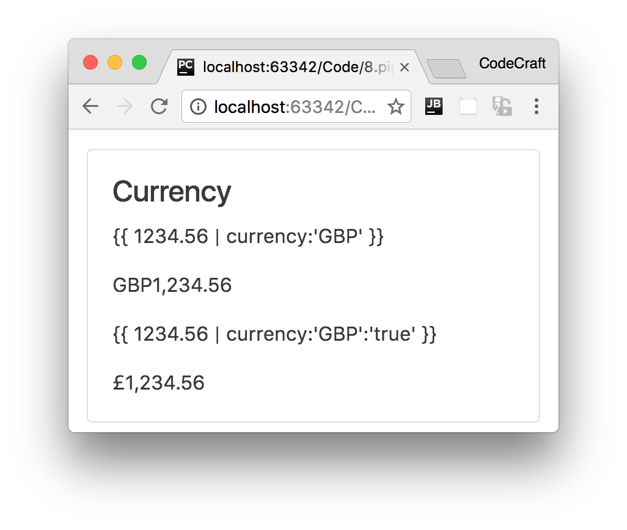

<

div class="card card-block"

>

<h4 class="card-title">Currency</h4>

<div class="card-text">

<p ngNonBindable>{{ 1234.56 | currency:'GBP' }}</p>

<p>{{ 1234.56 | currency:"GBP" }}</p>

<p ngNonBindable>{{ 1234.56 | currency:'GBP':'true' }}</p>

<p>{{ 1234.56 | currency:"GBP":true }}</p>

</div>

<

/div

>

### DatePipe

This pipe is used for the transformation of dates. The first argument is a format string, like so:

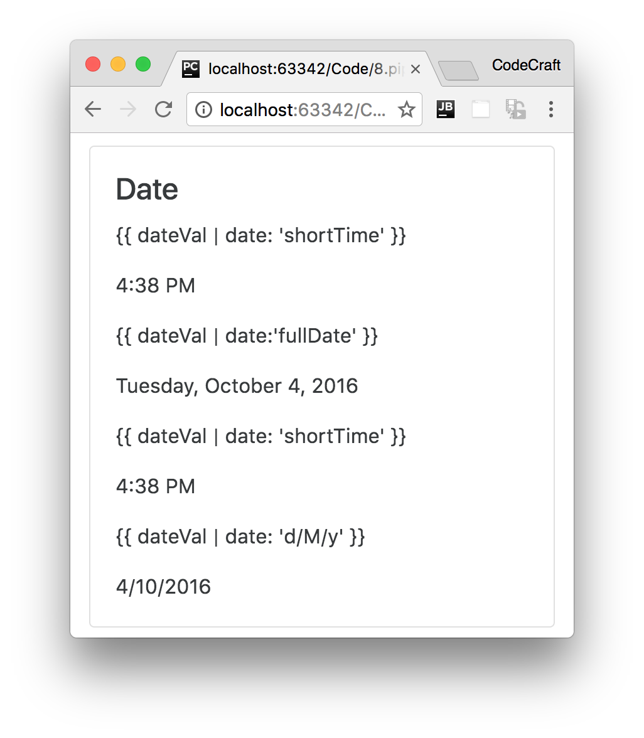

<div class="card card-block">

<h4 class="card-title">Date</h4>

<div class="card-text">

<p ngNonBindable>{{ dateVal | date: 'shortTime' }}</p> ①

<p>{{ dateVal | date: 'shortTime' }}</p>

<p ngNonBindable>{{ dateVal | date:'fullDate' }}</p>

<p>{{ dateVal | date: 'fullDate' }}</p>

<p ngNonBindable>{{ dateVal | date: 'd/M/y' }}</p>

<p>{{ dateVal | date: 'd/M/y' }}</p>

</div>

</div>

①dateVal is an instance of new Date().

### DecimalPipe

This pipe is used for transformation of decimal numbers.

The first argument is a format string of the form "{minIntegerDigits}. {minFractionDigits}{maxFractionDigits}", like so:

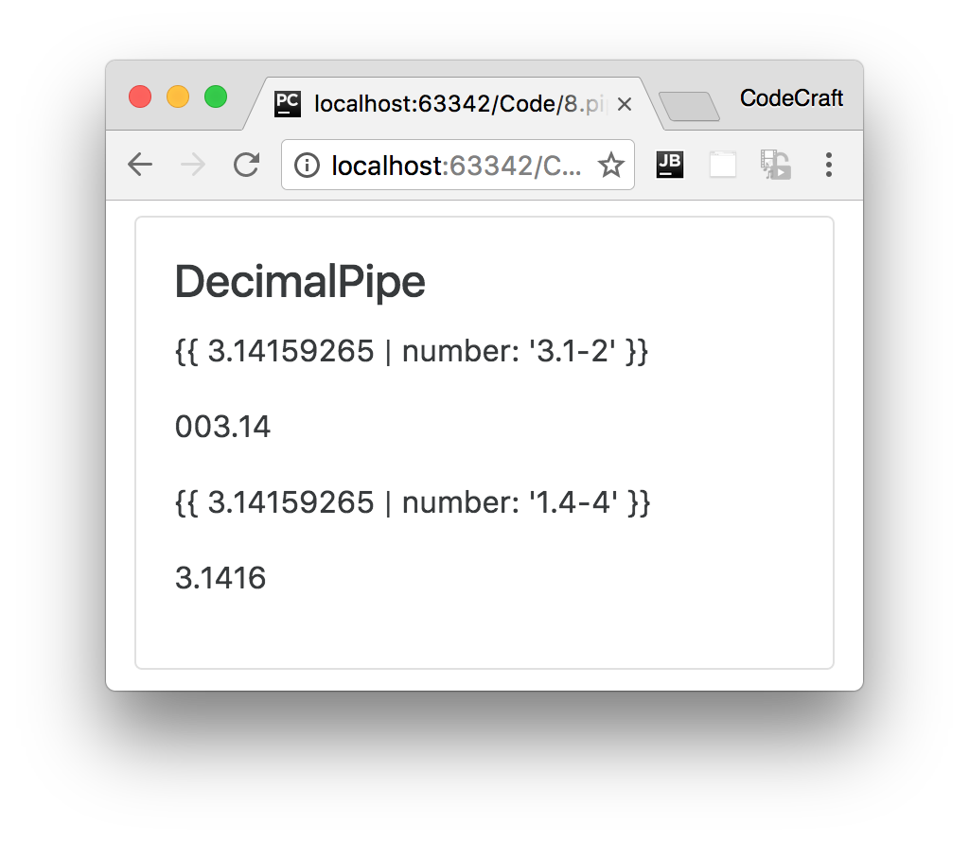

<div class="card card-block">

<div class="card-text">

<h4 class="card-title">DecimalPipe</h4>

<p ngNonBindable>{{ 3.14159265 | number: '3.1-2' }}</p>

<p>{{ 3.14159265 | number: '3.1-2' }}</p>

<p ngNonBindable>{{ 3.14159265 | number: '1.4-4' }}</p>

<p>{{ 3.14159265 | number: '1.4-4' }}</p>

</div>

</div>

### JsonPipe

This transforms a JavaScript object into a JSON string, like so:

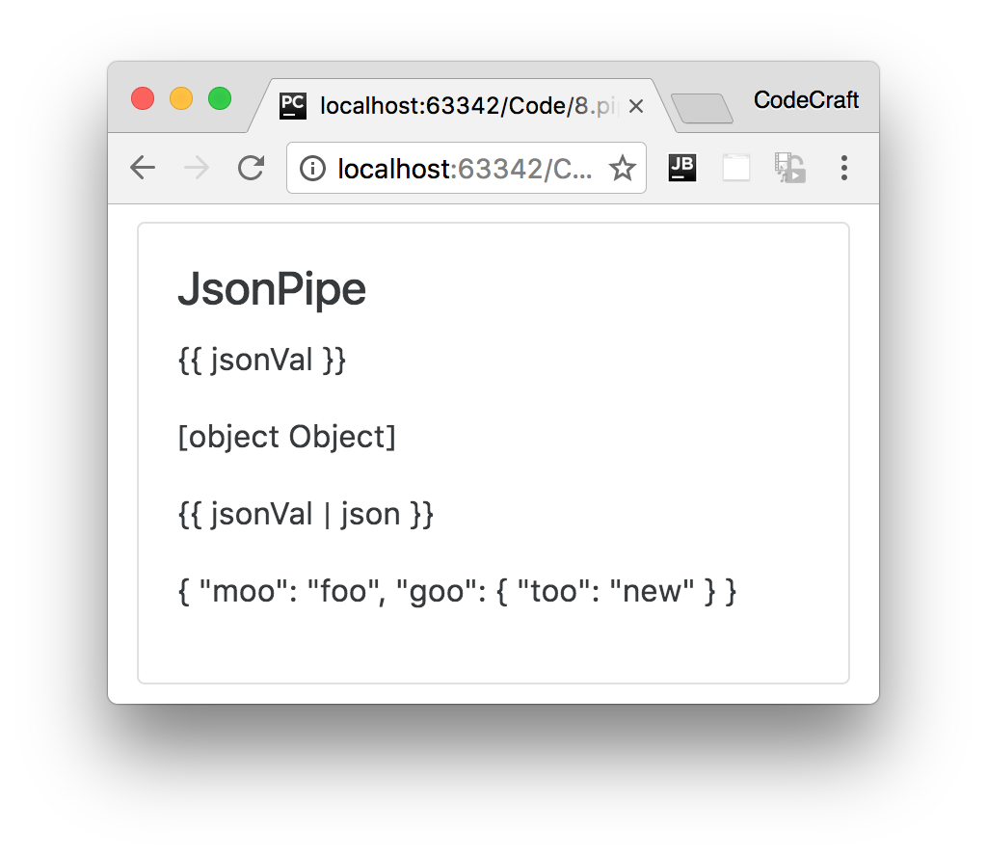

<

div class="card card-block"

>

<h4 class="card-title">JsonPipe</h4>

<div class="card-text">

<p ngNonBindable>{{ jsonVal }}</p>

①

<p>{{ jsonVal }}</p>

<p ngNonBindable>{{ jsonVal | json }}</p>

<p>{{ jsonVal | json }}</p>

</div>

<

/div

>

①jsonVal is an object declared as { moo: 'foo', goo: { too: 'new' }}.

### LowerCasePipe

This transforms a string to lowercase, like so:

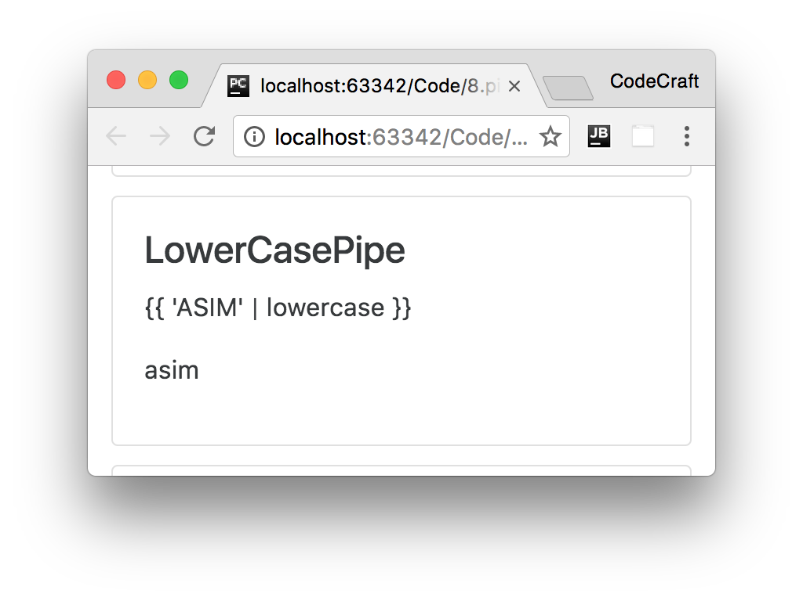

<

div class="card card-block"

>

<h4 class="card-title">LowerCasePipe</h4>

<div class="card-text">

<p ngNonBindable>{{ 'ASIM' | lowercase }}</p>

<p>{{ 'ASIM' | lowercase }}</p>

</div>

<

/div

>

### UpperCasePipe

This transforms a string to uppercase, like so:

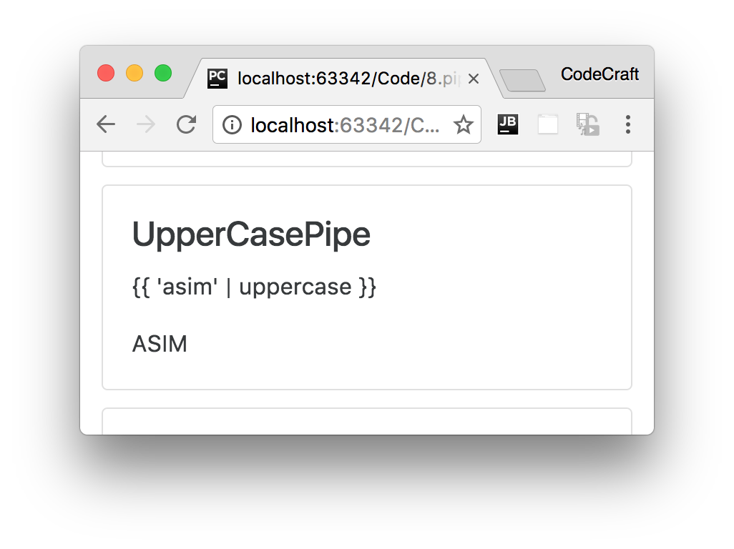

<

div class="card card-block"

>

<h4 class="card-title">UpperCasePipe</h4>

<div class="card-text">

<p ngNonBindable>{{ 'asim' | uppercase }}</p>

<p>{{ 'asim' | uppercase }}</p>

</div>

<

/div

>

### PercentPipe

Formats a number as a percent, like so:

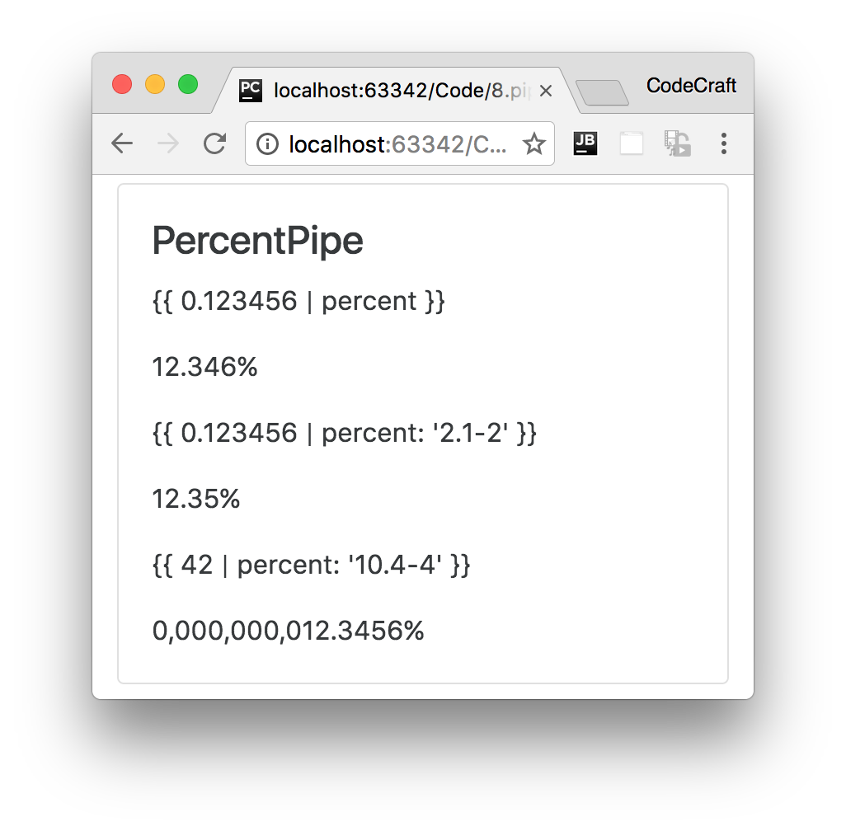

<div class="card card-block">

<h4 class="card-title">PercentPipe</h4>

<div class="card-text">

<p ngNonBindable>{{ 0.123456 | percent }}</p>

<p>{{ 0.123456 | percent }}</p>

<p ngNonBindable>{{ 0.123456 | percent: '2.1-2' }}</p> ①

<p>{{ 0.123456 | percent: '2.1-2' }}</p>

<p ngNonBindable>{{ 42 | percent: '10.4-4' }}</p>

<p>{{ 0.123456 | percent : "10.4-4" }}</p>

</div>

</div>

① Percent can be passed a format string similar to the format passed to the DecimalPipe.

### SlicePipe

This returns a *slice* of an array. The first argument is the start index of the slice and the second argument is the end index.

If either indexes are not provided it assumes the start or the end of the array and we can use negative indexes to indicate an offset from the end, like so:

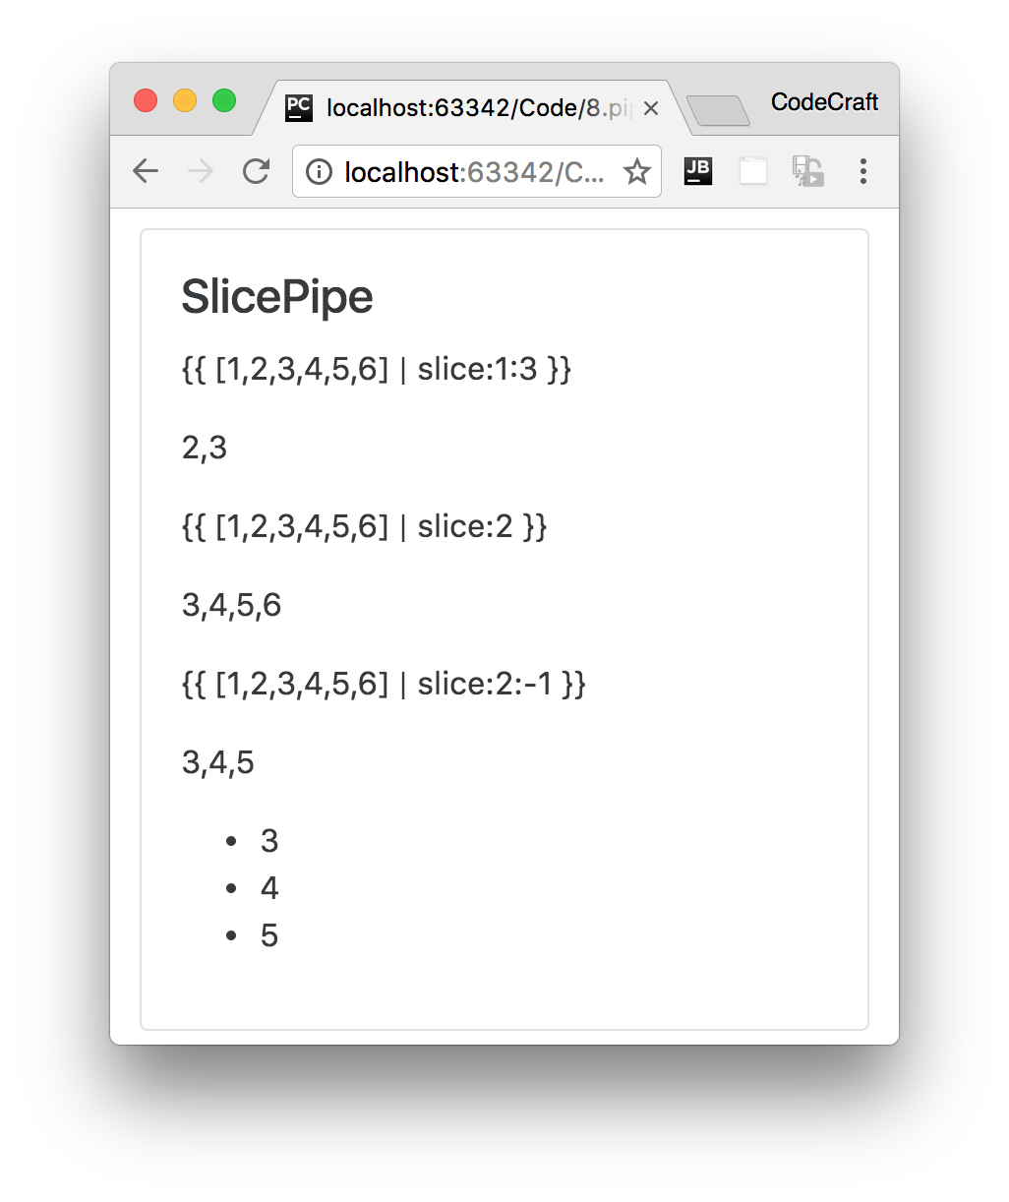

<

div class="card card-block"

>

<h4 class="card-title">SlicePipe</h4>

<div class="card-text">

<p ngNonBindable>{{ [1,2,3,4,5,6] | slice:1:3 }}</p>

①

<p>{{ [1,2,3,4,5,6] | slice:1:3 }}</p>

<p ngNonBindable>{{ [1,2,3,4,5,6] | slice:2 }}</p>

②

<p>{{ [1,2,3,4,5,6] | slice:2 }}</p>

<p ngNonBindable>{{ [1,2,3,4,5,6] | slice:2:-1 }}</p>

③

<p>{{ [1,2,3,4,5,6] | slice:2:-1 }}</p>

<pre ngNonBindable>

&lt;ul&gt;

&lt;li *ngFor=&quot;let v of [1,2,3,4,5,6] | slice:2:-1&quot;&gt;

{{v}}

&lt;/li&gt;

&lt;/ul&gt;

</pre>

<ul>

<li *ngFor="let v of [1,2,3,4,5,6] | slice:2:-1">

④

{{v}}

</li>

</ul>

</div>

<

/div

>

①slice:1:3 means return the items from the 1st to the 3rd index inclusive (indexes start at 0).

②slice:2 means return the items from the 2nd index to the end of the array.

③slice:2:-1 means return the items from the 2nd index to one from the end of the array.

④ We can use slice inside for loops to only loop over a subset of the array items.

### AsyncPipe

This pipe accepts an observable or a promise and lets us render the output of an observable or promise without having to call then or subscribe.

We are going to take a much deeper look at this pipe at the end of this section.

**Summary**

Pipes enables you to easily transform data for display purposes in templates.

Angular comes with a very useful set of pre-built pipes to handle most of the common transformations.

One of the more complex pipes to understand in Angular is the async pipe that’s what we’ll cover

next.

**Listing**

<http://plnkr.co/edit/UG4SwlJ0DQEGjkhbbQz9?p=preview>

*script.ts*

import {NgModule, Component} from '@angular/core'; import {BrowserModule} from '@angular/platform-browser';

import {platformBrowserDynamic} from '@angular/platform-browser-dynamic';

@Component({

selector: 'pipe-builtins',

template: `<div class="card card-block">

<h4 class="card-title">Currency</h4>

<div class="card-text">

<p ngNonBindable>{{ 1234.56 | currency:'CAD' }}</p>

<p>{{ 1234.56 | currency:"CAD" }}</p>

<p ngNonBindable>{{ 1234.56 | currency:'CAD':'code' }}</p>

<p>{{ 1234.56 | currency:'CAD':'code'}}</p>

<p ngNonBindable>{{ 1234.56 | currency:'CAD':'symbol' }}</p>

<p>{{ 1234.56 | currency:'CAD':'symbol'}}</p>

<p ngNonBindable>{{ 1234.56 | currency:'CAD':'symbol-narrow' }}</p>

<p>{{ 1234.56 | currency:'CAD':'symbol-narrow'}}</p>

</div>

</div>

<div class="card card-block">

<h4 class="card-title">Date</h4>

<div class="card-text">

<p ngNonBindable>{{ dateVal | date: 'shortTime' }}</p>

<p>{{ dateVal | date: 'shortTime' }}</p>

<p ngNonBindable>{{ dateVal | date:'fullDate' }}</p>

<p>{{ dateVal | date: 'fullDate' }}</p>

<p ngNonBindable>{{ dateVal | date: 'shortTime' }}</p>

<p>{{ dateVal | date: 'shortTime' }}</p>

<p ngNonBindable>{{ dateVal | date: 'd/M/y' }}</p>

<p>{{ dateVal | date: 'd/M/y' }}</p>

</div>

</div>

<div class="card card-block">

<div class="card-text">

<h4 class="card-title">DecimalPipe</h4>

<p ngNonBindable>{{ 3.14159265 | number: '3.1-2' }}</p>

<p>{{ 3.14159265 | number: '3.1-2' }}</p>

<p ngNonBindable>{{ 3.14159265 | number: '1.4-4' }}</p>

<p>{{ 3.14159265 | number: '1.4-4' }}</p>

</div>

<

/div

>

<

div class="card card-block"

>

<h4 class="card-title">JsonPipe</h4>

<div class="card-text">

<p ngNonBindable>{{ jsonVal }}</p>

<p>{{ jsonVal }}</p>

<p ngNonBindable>{{ jsonVal | json }}</p>

<p>{{ jsonVal | json }}</p>

</div>

<

/div

>

<

div class="card card-block"

>

<h4 class="card-title">LowerCasePipe</h4>

<div class="card-text">

<p ngNonBindable>{{ 'ASIM' | lowercase }}</p>

<p>{{ 'ASIM' | lowercase }}</p>

</div>

<

/div

>

<

div class="card card-block"

>

<h4 class="card-title">UpperCasePipe</h4>

<div class="card-text">

<p ngNonBindable>{{ 'asim' | uppercase }}</p>

<p>{{ 'asim' | uppercase }}</p>

</div>

<

/div

>

<

div class="card card-block"

>

<h4 class="card-title">PercentPipe</h4>

<div class="card-text">

<p ngNonBindable>{{ 0.123456 | percent }}</p>

<p>{{ 0.123456 | percent }}</p>

<p ngNonBindable>{{ 0.123456 | percent: '2.1-2' }}</p>

<p>{{ 0.123456 | percent: '2.1-2' }}</p>

<p ngNonBindable>{{ 42 | percent: '10.4-4' }}</p>

<p>{{ 0.123456 | percent : "10.4-4" }}</p>

</div>

<

/div

>

<

div class="card card-block"

>

<h4 class="card-title">SlicePipe</h4>

<div class="card-text">

<p ngNonBindable>{{ [1,2,3,4,5,6] | slice:1:3 }}</p>

<p>{{ [1,2,3,4,5,6] | slice:1:3 }}</p>

<p ngNonBindable>{{ [1,2,3,4,5,6] | slice:2 }}</p>

<p>{{ [1,2,3,4,5,6] | slice:2 }}</p>

<p ngNonBindable>{{ [1,2,3,4,5,6] | slice:2:-1 }}</p>

<p>{{ [1,2,3,4,5,6] | slice:2:-1 }}</p>

<pre ngNonBindable>

&lt;ul&gt;

&lt;li *ngFor=&quot;let v of [1,2,3,4,5,6] | slice:2:-1&quot;&gt;

{{v}}

&lt;/li&gt;

&lt;/ul&gt;

</pre>

<ul>

<li *ngFor="let v of [1,2,3,4,5,6] | slice:2:-1">

{{v}}

</li>

</ul>

</div>

>

<

/div

`

})

class PipeBuiltinsComponent {

private dateVal: Date = new Date();

private jsonVal: Object = {moo: 'foo', goo: {too: 'new'}};

}

@Component({

selector: 'app',

template: `

<

pipe-builtins></pipe-builtins

>

`

})

class AppComponent {

}

@NgModule({

imports: [BrowserModule],

declarations: [AppComponent,

PipeBuiltinsComponent

],

bootstrap: [AppComponent],

})

class AppModule {

}

platformBrowserDynamic().bootstrapModule(AppModule);